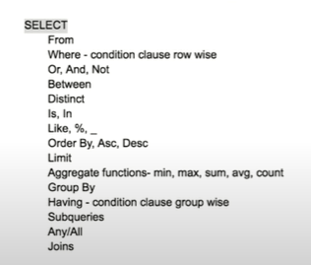

Customer

CustomerID CustomerName Address City PostalCode Country Age

**From**

Select * from Customer

Select customerID, customerName from Customer

**Where**

Having is a condition clause. It checks row wise.

Select * from Customer where Country = “Bangladesh”

**Or/And/Not**

Select * from Customer where Country != “Bangladesh”(not)

Select * from Customer where Country <> “Bangladesh”(another symbol for not)

Select * from Customer where Country = “Bangladesh” And City = “Dhaka”(and)

Select * from Customer where Country = “Bangladesh” OR Country = “India”(and)

**Between**

Select * from Customer where Age >= 18 AND Age <= 25

We can write,

Select * from Customer where Age Between 18 and 25

Select * from Customer where Age >= 18 AND Age <= 25 not in the region. Then we can write,

Select * from Customer where Age NOT Between 18 and 25

**Distinct**

Select Distinct Country from Customer (for avoiding repetition, unique value)

Select Distinct Country, Distinct City from Customer

**Is/In**

Select * from Customer where Address is Null(for Null values we have to use is instead of =)

Select * from Customer where Address is Not Null

Select * from Customer where City = “Dhaka” or City = “Sylhet” or City = “Ctg”

We can write it as,

Select * from Customer where City in (“Dhaka” , “Sylhet”, “Ctg”)

**Like**

Select * from Customer where Address Like “Dhanmondi”

Its for match with the substrings

Because there are lot of info in address column as block no,flat no,road no, dhanmondi

**%(percentage)**

It replaces zero or more characters.

%dhanmondi means there can be zero or more characters but it doesnt matter.

It also means dhanmondi is the last word.

But if we use %dhanmondi% then the word can be anywhere in the middle and other characters doesn't matter

If we want to see address from dhanmondi and mohakhali we can write,

Select * from Customer where Address Like “%Dhanmondi%” or Address Like “%mohakhali%”

If we want to find a customer name that starts with A and ends with a we can write,

Select * from Customer where customerName Like “A%a”

So it will work for the name of Ayesha

**_ (underscore)**

It can ignore one character only.

Select * from Customer where customerName Like “A_a”

So it will work for the name of Ana

Select * from Customer where customerName Like “A__a”

So it will work for the name of Anna

**Order by**

Select * from Customer Order by Age desc, PostalCode Asc

From this it can order the age. Then if the age is the same then it will use postal code in asc order. That's how the first column will get the priority and then 2nd and then 3rd and on.

**Limit**

Select * from Customer Order by Age desc Limit 5

That's how we can see the 5 most senior customer

**min/max/sum/avg/count**

Select min(Age) from Customer

Select max(Age) from Customer

Select sum(Age) from Customer

Select avg(Age) from Customer

Select count(*) from Customer(it will count the total number of customers)

**Group by**

Select count(*) from Customer group by Country

It will give the no of customers per country

Select count(*),Country from Customer group by Country

It will give the country and then the no of customers per country

Select avg(Age),Country from Customer group by Country

It will give the avg age of each country

**Having**

Having is a condition clause. It checks group wise. It will check the condition in the entire group. Its normally used for group by or min/max/avg/sum/count informations

Select avg(Age),Country from Customer group by Country Having Count(*)>10

It will give the avg age of a country if that group have more than 10 customers

**Subqueries**

We use it when the value is unknown.this value usually changes.

Select * from Customer where Age = ?

Here we want to put the max age but it's unknown and everytime it changes the value if a new item inserts. So we use subqueries.

Select * from Customer where Age = (select max(age) from customer)

It will show the max age customer from all the customers

Select * from Customer where (Country,Age) = (Select Country,max(age) from Customer group by country

It will give the max age customer per country. So it will return multiple values. = sign returns one value. So we can’t use = sign. So we will use In,

Select * from Customer where (Country,Age) In (Select Country,max(age) from Customer group by country

Lhs and rhs have to match. We can't write (city,age)or(age,country) in lhs and in rhs there is (country,age)

Any/All

Select * from Customer where Country = “Bangladesh” and Age < All(Select Age from Customer where Country = “India”)

First it will go to the bangladesh then in the age group then it will go in the indian age group. It will have to be less than all the Indian customer ages.

Select * from Customer where Country = “Bangladesh” and Age < Any(Select Age from Customer where Country = “India”)

First it will go to the bangladesh then in the age group then it will go in the indian age group. It will have to be less than at least one of the Indian customer age.

Joins

Didn’t give info. Class a bolse pore.

Sequence need to maintain:

1.Select

2.From

3.Where

4.Group by

5.Having

6.Order by

Lab 4 and lab 7 practice

Final = 1.45 - 2 h

Marks will be 40-45 converted to 30

4 questions. All have to answer

Chap = 5,7,8

LAB 3:

4.

select department_id, count(*) from employees where employee_id in (select employee_id from employees where salary>69000) group by department_id ;

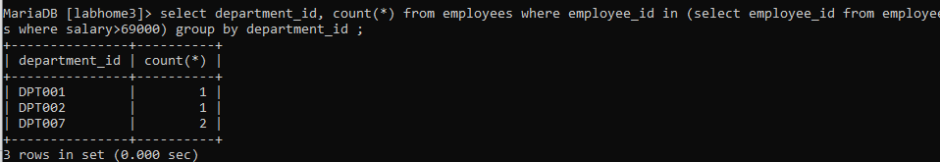

Here it check all employees so even tho it’s grouping by dept still counting only the times it finds emp id on the nested

Otherwise;

select department_id, count(*) from employees where department_id in (select department_id from employees where salary>69000) group by department_id ;

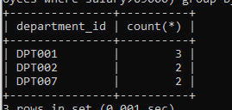 checks each time it finds a dept

6.

select distinct manager_id from employees where (manager_id,employee_id) in

(select manager_id,employee_id from employees where salary>55000);

